Lowry Burgess and Kristen Burgess Agee

Moments in the Infinite Absolute

United States

Burgess’s monumental work, ‘The Seed of the Infinite Absolute’ will float in microgravity above Los Angeles, generating brilliant flashes of light as it transits from OG to 2Gs. It is formed by an elaborate series of processes and distillations created, in different global climates, over the past 25 years. Its shell, a geometrically complex, hand size ‘seed’ is a fusion of the 12 ‘royal’ metals. It contains a unified emulsion of the essences of 44 trees, 52 flowers, 36 waters, 32 bloods and 120 telepathic hopes representing, in essence, the entire Earth. All these elements are unified into one essential, hand-held form to be ‘released’ by the artist at the edge of the absolute state of micro-gravity.

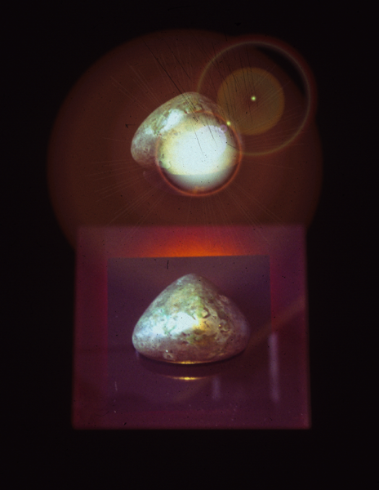

The Seed of the Infinite Absolute by Lowry Burgess, 2005

The concept for this artwork in micro-gravity is the simple gesture of release from a human hand of the hand-sized form of "the Seed of the Infinite Absolute" into repeated moments of weightlessness (moments of 'equant' balance) and double-density/double-gravity weighted ness. (It is actually quite a dense and heavy small pear sized object). At the moment of its weightlessness, it flashes with bright white stroboscopic light (the flashing brilliance of its approach to the Absolute).

The "Seed of the Infinite Absolute” is a distilled seed-form which by its nature establishes an entity which is the unit, root, measure, proportion/portion of the single one' or the absolute unit or measure of this cosmos -- its source and end. It is the geometric and ritualistic gravitational center of a nest of infinities within the larger artwork called the "Quiet Axis".

The "Seed of the Infinite Absolute' is formed by an elaborate series of processes and distillations over the past 25 years. The shell of the ‘seed’ is a meld of 12 metals ‘distilled’ at the foot of Mount Whitney and ‘poured from the sun’ at twilight. This shell contains an emulsion of the essences of 44 trees, 52 flowers, 36 waters, 32 bloods and 120 hopes. In it all these are brought together into one essential form.

Tania Fraga, David King, Frank Pietronigro and Gavin Starks

Gravity Fluxions: Pulsations
Brazil, United States, United Kingdom

The artists plan to conduct, during parabolic flight, a performance testing an experimental hypothesis on the spatial behavior of a fluid rubber structure created with materials, currently being researched, that aim to be used for sustained development projects supporting small communities in the Amazon. Considered as an artificial organism' by the artists, the structure will grow in weightlessness, floating with the body of the artist, from total flatness to a three-dimensional volume.

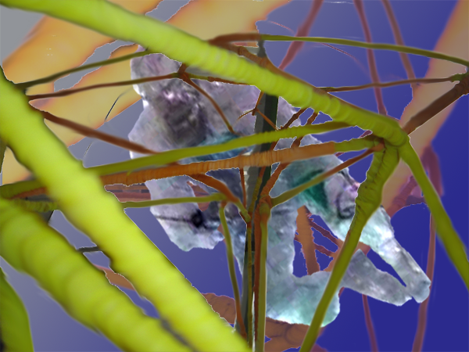

Gravity Fluxions:: Pulsations,
Digital Media Simulation by Frank Pietronigro, 2005

To extend a metaphorical experience of fluidity and weightlessness to earthbound audiences, the artists can create a responsive installation as a part of the ISDC2006 Space Art Exhibition, using ultraviolet light over a responsive rubber structure embedded with programmable sensors to produce fluid movements. It is the intention of the artists that this work will reconstruct for earthbound viewers a poetic sense similar to what happens to people in microgravity: immersion, disorientation, ephemeral sensations, lack of verticality and instability.

Gavin Starks will also attempt to directly affect the shape and movement of the ‘artificial being’ by playing sound directly at the ‘artificial being’ - making it resonate at certain frequencies, while using a strobe light or high shutter-speed camera to macro-film its surface. Certainly given the fluid nature of the object and the links with "acoustic" resonant phenomena being discovered in everything from galactic dust clouds to black holes, there are many references relative to this project convention. For example, "resonant" frequencies in cosmological models will be experimented with as the artists will take "standard 3d visual references" for cosmological models, such as the "saddle" topology and then create some form of resonance to change this topology into something else using the memory of the material contained in the ‘artificial being’. Even a planar surface of the ‘artificial being’ would yield an interesting, malleable aesthetic.

Depending upon the fluidity of the ‘artificial being’ the artist intends to encourage a significant spatial change and / or shorten the experiment, film it at high speed, and then replay the effect slowly.

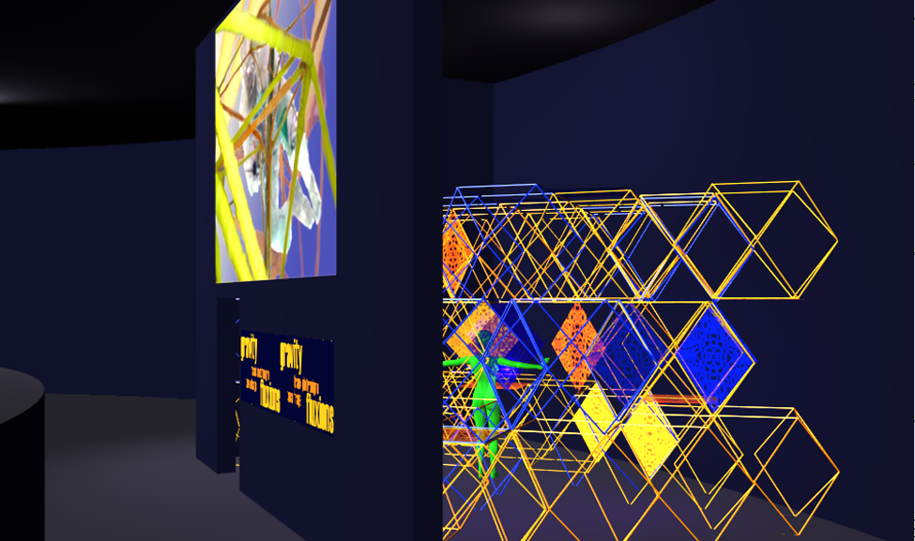

Gravity Fluxions: Simulation, A View of the installation showing audience interacting with the ‘Artificial Being”
Project Visualization by Tania Fraga

When asking why and how the artist’s role may influence space exploration and how the presence of artists impacts various technologies and issues associated with human space travel, while also considering the questions as to why humans should go into space at all when it is cheaper and easier to have space explored by robots; we began to see an answer emerging that inferences the imperative to carry our human sensibilities and sensitivities out to space, something the robots of our time cannot do. Our project sets up a contrasts and a complimentary bridge between an ‘artificial being’ and human beings with the intention that an ISDC2006 audience will also reflect upon such questions. Since artists are not constrained by methodologies that may inhibit free speculations and their subjectivity is trained to explore its own mind realm, the objective and subjective sides of knowledge become more balanced through such art and science collaborations.

Project Affiliate Institutions include: Exequo, the Open Broadcast Network, United Kingdom; General Orbital Corporation, United States; Goianesia Communities, Brazil; ItauLab - Itau Cultural Institute, Sao Paulo, Brazil; Itau Cultural Institute; Lateq/UnB – Laboratory of Applied Chemistry from the University of Brasilia, Brazil; Philcorp, United States, Skedio Technologies, Brazil, Zero Gravity Arts Consortirum, United States.

ABOUT THE ARTISTS

LOWRY BURGESS
United States

Lowry Burgess has worked with outer space for the past 35 years. Among celebrated space artworks is his ‘Boundless Cubic Lunar Aperture,’ as noted, the first ‘official’ non-scientific payload that was taken into outer space by the NASA Space shuttle Discovery in March 1989. He is Dean and Professor at Carnegie Mellon University and Distinguished Fellow of the Studio for Creative Inquiry and the Center for the Arts and Society. He was a Fellow of the Center for Advanced Visual Studies at MIT for 25 years.

URLs:
http://artscool.cfa.cmu.edu:16080/~burgess/
http://www.cmu.edu/PR/releases05/050210_spaceart.html

TANIA FRAGA
Brazil

Tania Fraga is a Brazilian architect and artist. She holds a PhD. of the Communication and Semiotics Program at the Catholic University of Sao Paulo (PUC). In the course of 1999, Tania developed a Post Doctoral research project at CAiiA-STAR, UK with a research grant from CAPES, the Brazilian Agency for the Improvement of Higher Education Personnel. She was Professor and Co-Coordinator of the Graduation Studies of the Art Institute at University of Brasilia, Brazil, where she is Associated Researcher. She was member of the Advisory Research Committee of the Banff New Media Centre in 2003, Canada. She was Visiting Scholar at the Computer Science Department at The George Washington University, Washington DC, 1991/1992 and Artist-in-Residence at The Bemis Foundation, USA, 1986, with a grant from the Fulbright Commission. She has been showing and publishing her work in many national and international exhibitions, lectures, workshops, seminars and congresses. Tania's current field of research is the creation of interactive cyber-worlds, for interactive stage performances and interactive art installations. They are based on 3D modeling, animation and VRML (Virtual Reality Modeling Language), JavaScript and Java 3D languages.

URLs:
www.lsi.usp.br/~tania/
www.unb.br/vis/lvpa/
planeta.terra.com.br/arte/lvpa2002/ResponsiveSurface/

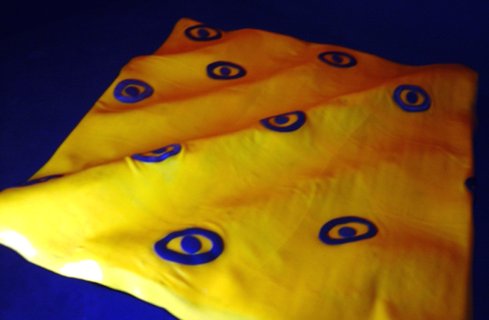

“Fluid Rubber Membrane”
Tania Fraga, Artist
An artificial organism commissioned by Itau Cultural Institute, Brazil, 2005

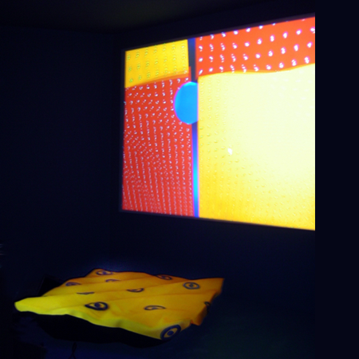

“Responsive Membrane”
Tania Fraga, Artist - An artificial organism in the context of an installation commissioned by Itau Cultural Institute, Brazil, 2005

FRANK PIETRONIGRO
United States

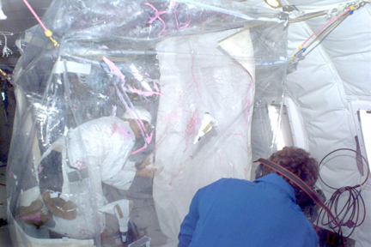

‘Drift Painting’ in a Microgravity Environment, Frank Pietronigro, Artist, 1998

(Original Video Footage: Courtesy of NASA)

Frank Pietronigro is an interdisciplinary artist, educator, and author residing in San Francisco, California. In 2004, Frank Pietronigro was appointed Associate Fellow at the Studio For Creative Inquiry at the College of Fine Arts, Carnegie Mellon University and currently serves as Co-Founder and Project Director of the Zero Gravity Arts Consortium (ZGAC), an international space arts organization that is dedicated to fostering greater access for artists to microgravity space and space flight technology. Frank also serves as Co-Chair for the 25th International Space Development Conference Space Art Track, a conference co-sponsored by the National Space Society and the Planetary Society that will be held in Los Angeles in 2006.

He served as Co-Organizer for the 2005 Workshop on Space Artist’s Residencies and Collaborations that was held at Carnegie Mellon University West at the NASA Ames Research Center at Moffett Field, California. As Project Founder of Research Project Number 33: Investigating the Creative Process in a Microgravity Environment, Frank Pietronigro became the first American painter to create ‘drift paintings’ while he and the painting floated in zero gravity aboard NASA’s KC135 turbojet.

The artist has presented and published his work during lectures, workshops and congresses at national and international galleries, museum and other institutions including: Maison Europeenne de la Photographie, Paris, France; Biennale Internationale Dell’Arte Contemporanea, Florence, Italy; Smart Project Space, Amsterdam, The Netherlands; Museum Fur Gestaltung, Zurich, Switzerland; Galeria Ze Dos Bois, Lisbon, Portugal; and the Atlanta Contemporary Arts Center. Pietronigro received his Bachelor of Fine Arts in 1996 from the San Francisco Art Institute in Interdisciplinary Arts and also received a certificate from the Multimedia Studies Program at San Francisco State University in 1998. He studied fine art at the Philadelphia College of Art from 1975 to 1977 and was appointed by the San Francisco Art Commission to direct the 39th Annual San Francisco Arts Festival. He also produced San Francisco's Art In The Park in 1982 and 1983.

URLS:
www.zgac.org
www.pietronigro.com
www.kqed.org/spark/artists-orgs/spaceart.jsp

GAVIN STARKS
United Kingdom

Gavin Starks is an astronomer, musician, entrepreneur as well as an expert in broadcasting on the internet. He holds a Master of Music degree in Computer-Music, 3-D Sound, Virtual Reality Audio and a second Master Degree in Astronomy, Physics, Mathematics and Computing from the University of Glasgow.

Currently, Gavin is the Managing Director of Consolidated Independent; a company aggregating the music catalogues of the Independent music labels (e.g. Beggars Group) and piping them into Digital Music Services (e.g. iTunes, Napster). He is also Founder and Director of Exequo ltd, an open, non-profit,
collaborative Internet broadcasting network working with NGO's, community collectives and artists. He is Founder and CEO of Tornado Productions Ltd. a company that is involved in every aspect of creating and running one of the largest webcasting companies in Europe. He is also Aggregator and Founder d::gen network Ltd., a collection of projects and people. He is founding member and now Chairman of the IWA-Europe, a consortium encouraging all forms of broadcasting on the Internet.

He served as Chief Technology Officer at AssetTV Ltd. a company leading the development and launch of a touch-screen, closed-network IP TV channel for the Financial Sector. He was Senior Consultant at Servecast Ltd. where he assisted product development, sales and business development. Servecast's acquisition of Tornado makes it the largest webcasting company in Europe. Gavin served as Strategic Consultant, Webcasting Producer, and Technical Manager for Virgin Net, where as employee #5, he was involved in the definition of the ISP, the development of content channels and pioneering webcasting. He worked as Experimental Officer, Jodrell Bank, Radio Astronomy, Quasar Research, Software Development, Web Development, and Tutoring

URLs: www.dgen.net

